READ WISE

An eBook application

Task 2

Name: Afrah Said AL-Nabhani

GCET ID: 201811118

UWE ID: 19047536

Module Title: Mobile Applications

Module Code: UFCF7H-15-3

Module Tutors/ Leader: Dr. Muzammil Hussain

**ABSTRACT**

One of the greatest methods to keep customers interested in a business while they are on move is through mobile applications. The demand for mobile applications has increase due to the rise in popularity of smart phones and the efficiency of wireless networks. Android is one of the most well-known open-source platforms, it provides full access to the framework APIs to developers so they can create innovative applications.

The library of read wise provides access to a wide array of resources, E-books, or electronic books. In recent years readers have increasingly turned to e-books for their research and leisure activities. Online marketplaces have made it easy to access texts at any time and from anywhere, including on the go.

**Stage One**

1. **Research**

A book in electronic format is called an eBook. It is read on the screen after being downloaded to a laptop, tablet, smartphone, PC, Mac, or other type of reading device. Like a printed book, it can have a table of contents, numbered pages, photographs, and graphics.

The idea of e-books was ethically introduced with the intention of saving money and time. The fact that e-books are so cost and time efficient is one of their most compelling advantages. The days of students shelling out hundreds of dollars for novels in bookshops are long gone. In addition, they needed to go from town to town in order to obtain the necessary content. They have instant access to anything these days thanks to the e-books in their pockets.

eBooks are portable and lightweight, making it easy to carry around. Instead of carrying multiple bulky books, one eBook reader can hold thousands of eBooks. It saves a lot of space- in your home and in your bag. One doesn’t have to worry about the storage limit.

1. **Design**

An application's appearance and feel are referred to as its design. This covers every graphic and interactive component that affects how the application works.   
The two ideas of UI and UX are combined in mobile app design.

The user interface (UI) encompasses the app’s look and feel. It includes color, font, app style, and similar design choices. The user experience (UX) design prioritizes the app’s functions and use.

* 1. **User Flow Diagram**

An application's user flow is a diagram or chart that illustrates the steps a user will take to finish a task. Product teams create user flows to create products that are intuitive to use, deliver accurate information to users when it's needed, and let users finish activities in the fewest feasible steps. Figure.1 presents the application’s user flow diagram. when user opens the application, a welcome or splash activity with Lottie animation (as a book) will show. Then the user should Sign up to the app if he/she first uses to application, or login if he/she already has an account. After that the user can see the main activity contain all categories and they can find all type or most popular of books. They can choose the book and click to read button to read the book.

Book PDF

Book Details

All Categories

Main Activity

Login/Sign up Activity

Welcome Activity

Figure.1. Application’s user flow diagram

* 1. **User Interface (UI)**

User interface (UI) design is the visual layout of an item's digital interface, such as an app screen or website. It is the process of developing a visual experience's interactive and visual elements, making sure the interface is both aesthetically pleasing and user-friendly. Here, I organized the application's user interface as shown below. The application will launch on the welcome page for 5 seconds before switching to the main page. Then it will launch to the login/Sign up page Figure 2. Shows the welcome and login pages in sequence.

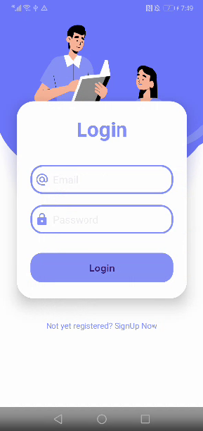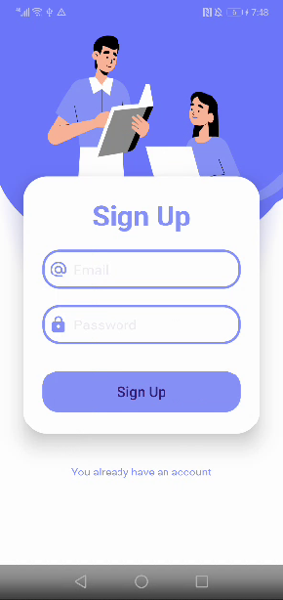

Figure.2. Welcome and sign up/login page of the application.

The app will present the dashboard or home page after the user successfully logs in or sing up. Since there are many options available, the user can choose whatever he/she wants to navigate. Figure 3 shows the user interface for the home page, which contain logout button and all categories. They can choose they favorite book to read easily.

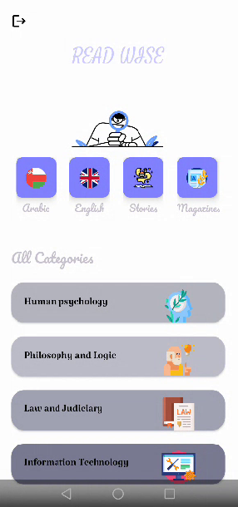

Figure.3. UI of the home page, categories and popular books.

The user can find many types of books and they are free to choose any book they want very easy. Figure.4. show the IT books section and there are a lot of choices.

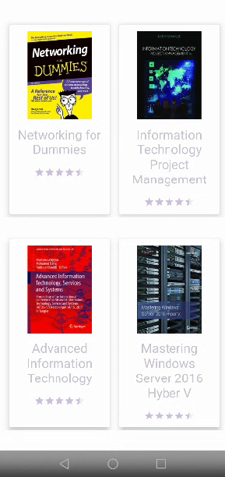

Figure.4. IT book section with different choices

After the user choose the desired book, it will take then to book details activity and they can find the book rate, book description and read button. Figure.5. can shows the one of IT book details and the after clicked to read button, the book pdf file will open and the user can read it clearly and free.

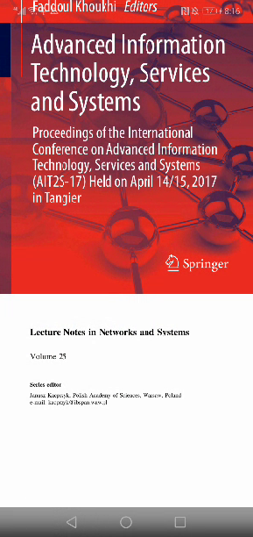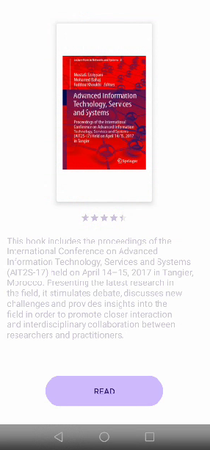

Figure.5. IT book details activity + book Pdf activity

1. **Requirements**

* **Market Research & Ideation**

While kickstarting eBook app development, first, conduct deep market research to know what’s buzzing around the globe in this segment, the ruling giants, and their weaknesses and strengths.

* **Planning and Design**

You have to lay out the project plan at this phase, emphasizing the features, functionalities, and development schedule. Your target market, the development platform you select, and your technical requirements are all up to you.

* **Development**

Select the proper tech stack, including the relevant frameworks and programming languages, during the development phase for your eBook application.

1. **Strategy**

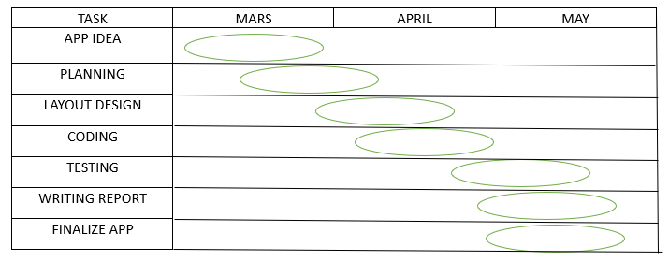Any project must follow a plan of tasks in order to succeed. Figure 6 explains the tasks and timetable for implementing the “READ WISE” application, which started in Mars until the end of May.

Figure.6. timeline table

1. **Conclusion**

The purpose of this project is to Read anytime, anywhere, One device, many books, Search in seconds and Customize how to read, and many many benefits and reasons to create or make this kind of apps.

1. **References**
2. Lone Thread Books.(2020) Why are E-books Important? [online]. Available from: <https://lonethread.medium.com/why-are-e-books-important-34376479c7ab#:~:text=eBooks%20are%20portable%20and%20lightweight,worry%20about%20the%20storage%20limit> [Accessed 12 May 2024]
3. Ian Blair. Mobile App Design: The Complete Designer’s Guide | BuildFire [online]. Available from: <https://buildfire.com/tools-for-mobile-app-designers/> [Accessed 12 May 2024]
4. Productplan. User Flow [online]. Available from: <https://www.productplan.com/glossary/user-flow/#:~:text=A%20user%20flow%20is%20a,as%20few%20steps%20as%20possible>. [Accessed 13 May 2024]
5. Naren Bhati.(2024) A Complete Guide To Develop Ebook Reader Mobile App. Available from: <https://www.emizentech.com/blog/develop-ebook-reading-app.html> [Accessed 14 May 2024]
6. DidYouKnow.(2020) 7 Benefits of E-Reading. Available from: <https://www.halifaxpubliclibraries.ca/blogs/post/7-benefits-of-e-reading/> [Accessed 15 May 2024]